**HUMAN RESOURCES SOFTWARE MODULE**

The following are the modules/sections included:

1. Recruitment
2. Hiring
3. Employee Information management
4. Salary/Leave entries and history

Expanding each modules:

**1. RECRUITMENT**

* Job Posting

Based on the approval of the board of management of the institution, the human resources officer in charge posts job offers online with application time frame.  
Que. 1: Will there be internal verbally discussion for the approval of the board of management of the institution? Or will there be new modules included to gets the approval of the job posting?

Req. : Do you have brief of requirement fields for the job posting? And do we need to make a new frontend for job posting? If yes please give us brief description for that.

* Sign up & sign in

The applicants view the job postings online and signs up using email address as username and surname + first initial as password.

After signing up, the user signs in with the above particulars to apply for targeted job by clicking on ‘apply now’ button.

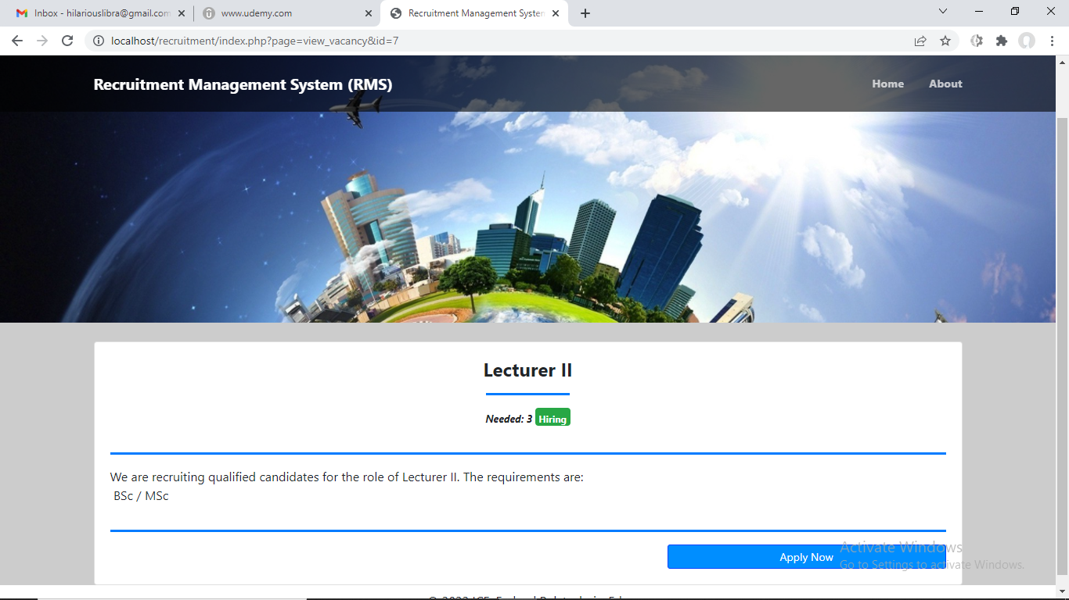

* Application ID generation and Application entry (cv preparation)

After clicking the ‘apply now’ button, the action pops up the registration form which the applicant fills by typing and uploading content based on the cv format provided online. After successful submission, an application ID will be generated for the applicant to track the application process.  
  
Please provide us the all fields of the application form.  
Que.: Any specific dynamic ID do you want?

* Shortlisting generates employee ID

The officer in charge of the recruitment exercise clicks on the ‘view application entry’ button to view all applications submitted. The preferred candidates that met the requirements for the job applications will be shortlisted for an interview.

After being shortlisted, applicant’s names will be sent to the provisional employment list. The applicant, with the aid of the application ID earlier generated, will be able to view the provisional employment offered to him and decide whether to accept or decline – all within a time frame specified by the management.

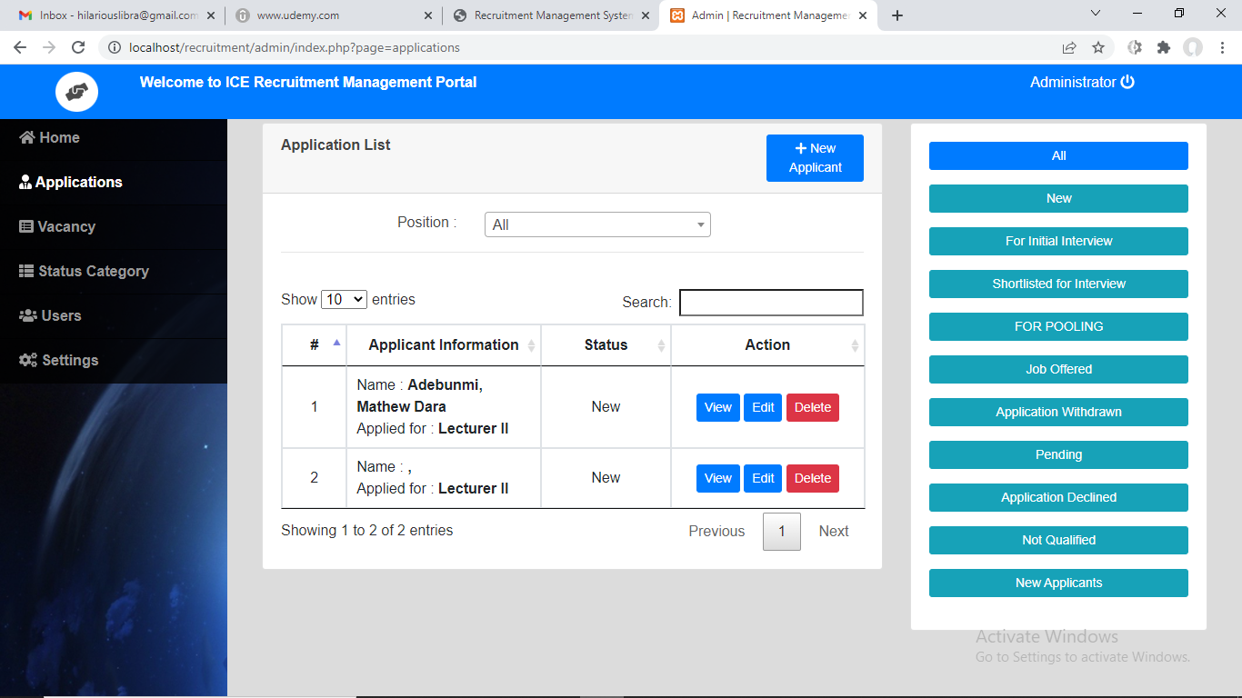

* Provisional Employment Acceptance & offer declination

**All declined provisional employments** will be **re-declared as provisional vacancy** of which any qualified applicant on the shortlist can be substituted for the declined candidates.

**For the acceptance**, an employment alert containing **login details (staff ID & password), information about job offered (department, designation, level, step…)** will be created and sent to the employed applicant, for them to login to the institution’s portal as a **prospective member of staff.**

**2. HIRING**

1. Job offer posting processing
2. View application entry
3. Shortlist applications
4. Review shortlisted applications for interview
5. View provisional employment list
6. View acceptance and declination reports
7. Process declined vacancies

**3. EMPLOYEE INFORMATION MANAGEMENT**

* **Employee Registration Details**

Logging in

After logging in, the prospective staff will have the opportunity of viewing their personal details and updating the other details that will be required for further processing by the human resources department.

The human resources officer reviews the submitted information and release the engagement information (job details) to the applicant.

* **Deployment, Transfer, Posting and Movement and History**

1. Initiate transfer

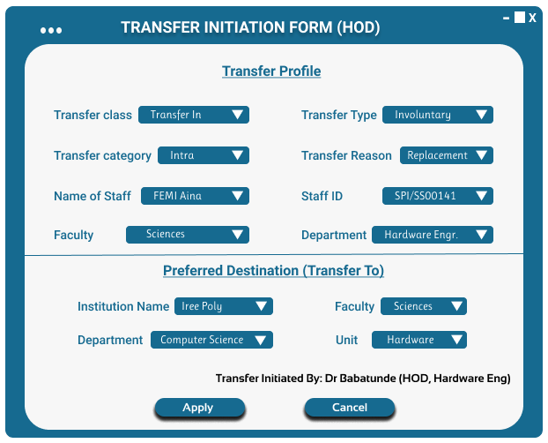

1. Process transfer

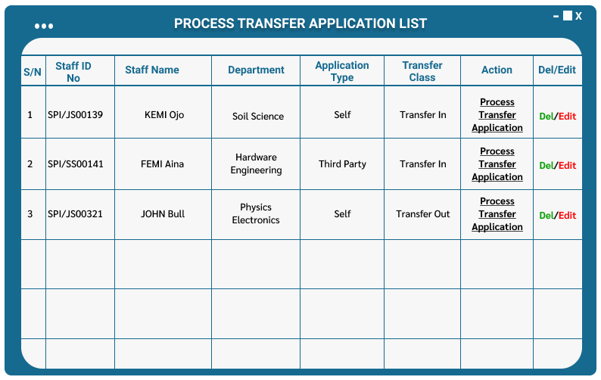

1. Authorize transfer

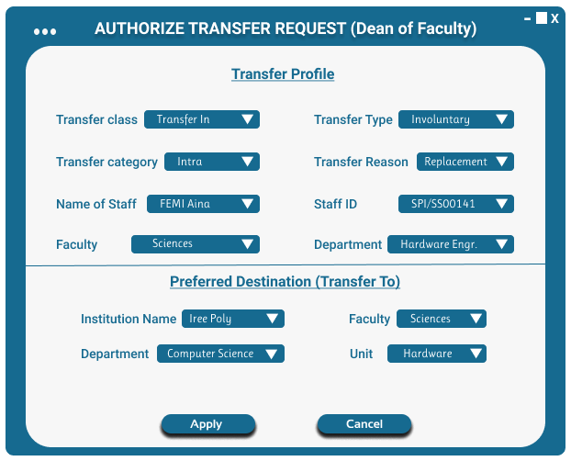

1. Review authorized transfer

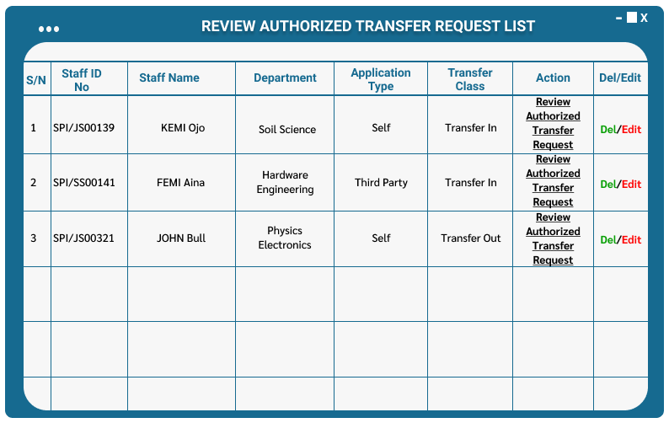

1. Approve transfer

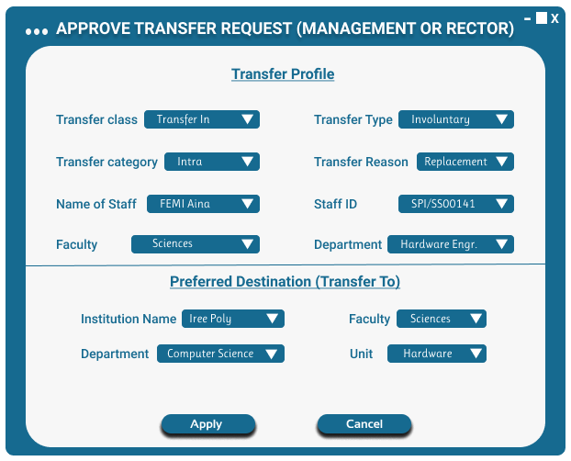

1. Authorize approved transfer

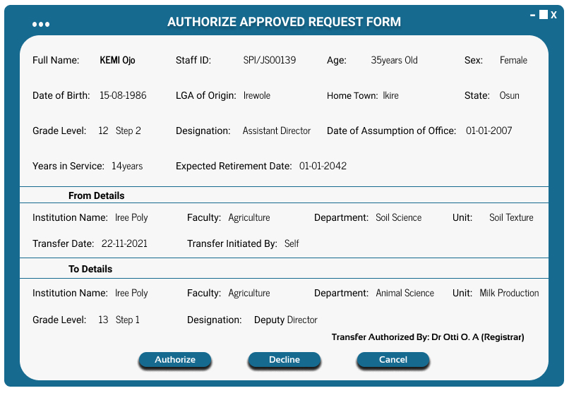

1. Check transfer request status

* **Disciplinary Entries and History**

When a staff violates any of the rules or working procedures in a department, a complaint/petition will be raised against such staff.

In response to the petition/complaint made, the Head of Department (HOD) may click the view complaints button to review complaint and issue Query to the reported staff.

RESPONSE POP DOWN MENU will contain list of available offences; query group or type; nature/type of offence that the reporting staff can select from.

The query form may contain the following fields:

* Name of the person to be served the query
* Staff ID
* Department
* Name of the Petitioner (Reporting staff)
* No of queries already received (link can be provided to view details)
* Nature of petition/complaint
* Reason for query (query title)
* Query date and time
* Query description

The HOD reviews the query either by clicking ‘warning’ checkbox, ‘discard query’ checkbox, or ‘recommend disciple’ checkbox.

When the warning checkbox is clicked, the number of queries will increase by 1.

When the discard checkbox is clicked, the query is immaterial and cancelled.

When the recommend discipline checkbox is clicked, the following discipline actions (query penalty) will pop out to select from:

1. Dismissal or termination of appointment
2. Suspension (definite – date of resumption specified, or indefinite (not specified)
3. Resignation – advice to resign to save the staff image
4. Retire involuntarily – forced to retire
5. Demotion - move to a lower grade level (reducing the number of modules they can access)
6. Transfer – transfer out to another unit/department office.

**Note:** when any of these above disciplines is recommended, it flows to a higher authority for further review which may be DISAPPROVED or APPROVED (if approved, the staff access to work modules will be disabled by displaying the approved recommended discipline on the screen to inform them when they try to login).

Reinstatement button is used to recall suspended or dismissed or retired staff after following laid down procedures guiding such action. The button, when clicked, reactivates the punished staff’s login.

**4. SALARY / LEAVE ENTRIES AND HISTORY**

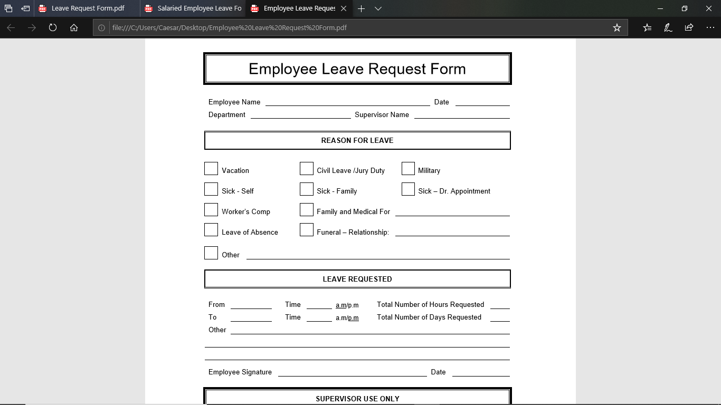

* Study leave
* Day Release
* Annual leave
* Maternity/Paternity leave
* Sick leave

**SOFTWARE MODULES**

The **new and existing staffers** will now have access to the following modules based on their levels of authorization and roles assigned to them:

A. VIEW

1. Registration details
2. Engagement details
3. Disengagement details
4. Job history (posting and transfer)
5. Disciplinary history (complaints & queries)
6. Request, Issues and Returns

B. REQUISITIONS

1. Transfer application
2. Leave application
3. Make request, issues and returns

C. COMPLAINTS

1. View complaints
2. Make complaints
3. Initiate complaints
4. Check complaint status
5. View query
6. Issue query
7. Reply query
8. Check query status